CSA1511-Cloud computing for big data an anaylist
ASSESMENT-8
S.Harshavardhan 192524106

Case Study 1: Smart Retail Inventory Management System

Introduction
A Smart Retail Inventory Management System is a cloud-based solution designed to help retail organizations manage products, sales transactions, inventory levels, and demand
forecasting efficiently. The system connects Point-of-Sale (POS) systems and management dashboards to centralized cloud services through APIs.
The use of cloud computing allows the retail chain to store large amounts of product and transaction data, analyze this information, and predict future product demand. This helps reduce stock shortages, avoid overstocking, and improve overall business operations.
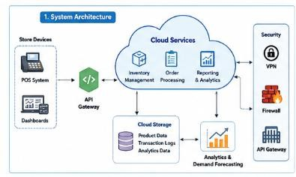

System Architecture
The system consists of several major components:

Client Layer
    - POS systems used by store employees.
    - Web-based dashboards used by managers and administrators.
    - Devices communicate with cloud services through APIs.

API Layer

    - APIs provide communication between clients and backend cloud services.
    - API gateways manage incoming requests.
    - They can provide authentication, request routing, monitoring, and rate limiting.

Cloud Application Services
    - Centralized cloud services process inventory and transaction requests.
    - Business logic handles stock updates, product information, sales processing, and reporting.

Cloud Storage
    - Stores product information.
    - Stores transaction and sales logs.
    - Stores analytics datasets.
    - Provides scalable storage as the retail business grows.

Analytics and Forecasting Services
    - Platform services analyze historical sales data.
    - Demand forecasting can predict future product requirements.
    - Analytics can identify popular products and sales trends.
  - 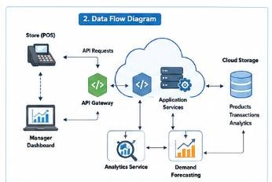

Security and Network Infrastructure
    - Firewalls protect cloud resources from unauthorized network access.
    - VPNs provide secure communication between stores and cloud infrastructure.

    - API gateways protect and control API access.

Cloud Service Models
The system can use all three major cloud service models:

Infrastructure as a Service (IaaS):
Virtual machines, networks, firewalls, and other infrastructure resources can be provided through cloud infrastructure services.

Platform as a Service (PaaS):
Managed analytics, databases, application platforms, and machine-learning/demand-forecasting services can be used without managing the underlying infrastructure.

Software as a Service (SaaS):
The inventory dashboard and business applications can be delivered to retail employees through web interfaces.

Benefits of Cloud Computing
The cloud-based approach provides several benefits:
- Scalability: Resources can be increased when transaction volumes grow.
- Availability: Centralized cloud services can be designed for continuous operation.
- Cost efficiency: The organization can reduce the need for maintaining large physical data centers.
- Centralized data: Product and transaction information can be accessed from different stores.
- Analytics: Large datasets can be processed to identify business trends.
- Demand forecasting: Historical data can be used to predict future demand.
- Remote accessibility: Authorized managers can access dashboards from different locations.

Security Measures
Security is essential because the system processes sales and business information. The following measures can be implemented:
- VPNs for secure communication between retail stores and cloud services.
- Firewalls to filter unauthorized network traffic.
- API gateways to control API requests.
- Authentication and authorization for users and devices.
- Encryption of sensitive information during transmission and storage.

- Role-based access control to restrict users according to their responsibilities.
- Monitoring and logging to detect suspicious activities.

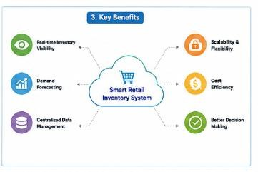

Conclusion
The Smart Retail Inventory Management System demonstrates how cloud computing can
integrate infrastructure, APIs, storage, analytics, and web applications into a single solution.
Cloud scalability and analytics capabilities allow retailers to manage inventory more
efficiently and make better business decisions. Security technologies such as VPNs, firewalls, and API gateways help protect the system and its data.

Case Study 2: Cloud-Based Document Collaboration System

Introduction
A Cloud-Based Document Collaboration System is an online platform that allows multiple users to create, edit, store, and share documents using web browsers. A system similar to Google Docs enables users to collaborate on the same document in real time.
Cloud computing makes it possible to store documents centrally while allowing users from different geographical locations to access and modify them. Version control ensures that changes can be tracked and previous versions can be recovered when required.
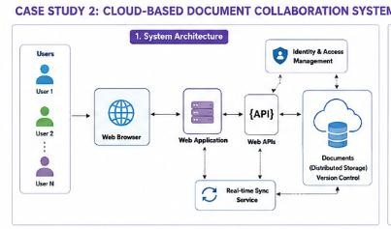

System Architecture
The system contains the following major components:

Client Layer
    - Web browsers are used to access documents.
    - Users can access the system using computers, tablets, and other devices.
    - Multiple users can work on the same document simultaneously.

Web Application Layer
    - Provides the user interface for document creation and editing.
    - Handles user requests and collaboration features.
    - Communicates with backend services through APIs.

Web API Layer
    - APIs synchronize changes between users and the cloud.
    - They allow different clients and devices to communicate with backend services.
    - APIs help maintain document state and collaboration information.

Cloud Storage
    - Documents are stored in distributed cloud storage.
    - Data replication can improve availability and reliability.
    - Version control mechanisms store previous versions of documents.

Network Infrastructure
    - Global cloud infrastructure provides access to users in different locations.
    - Load balancing and distributed services can reduce latency.
    - High availability ensures that users can access documents even if individual infrastructure components fail.

Security Layer
    - Encryption protects documents and user information.
    - Identity management verifies users.
    - Access permissions determine who can view, edit, or share a document.

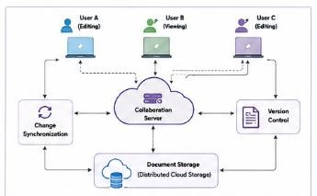

Cloud Service Models
Infrastructure as a Service (IaaS):
Cloud infrastructure such as servers, networking, and storage infrastructure supports the application.

Platform as a Service (PaaS):
Application platforms, databases, APIs, and managed services can be used to develop and operate the collaboration system.

Software as a Service (SaaS):
The complete document collaboration application is delivered to users through web browsers. Users do not need to install or manage the underlying software.
Therefore, this case study is primarily an example of Software as a Service (SaaS) supported by IaaS and PaaS components.

Real-Time Collaboration
Real-time collaboration is one of the most important features of the system. When one user makes a change to a document, the change must be synchronized with other connected users.
APIs and real-time communication mechanisms can be used to:
- Send document updates to users.
- Synchronize changes between devices.
- Maintain the current document state.
- Prevent or resolve conflicts between simultaneous edits.
- Update user interfaces without requiring constant page refreshes.

Version Control
Version control allows the system to maintain multiple versions of a document. For example:
- User A edits a document.
- The system saves the modification as a new version.
- User B makes additional changes.
- Another version is created.
- Users can review previous versions or restore an earlier version when necessary. This provides protection against accidental deletion or unwanted changes.

Security Measures
The system should implement strong security mechanisms, including:
- Encryption: Protects documents while being transmitted and stored.
- Identity management: Verifies the identity of users.
- Authentication: Ensures that only legitimate users can access accounts.
- Authorization: Controls what each user can do.
- Access permissions: Users can be given viewer, commenter, or editor permissions.

- Audit logs: Records important user activities.
- Secure APIs: Protects communication between clients and backend services.

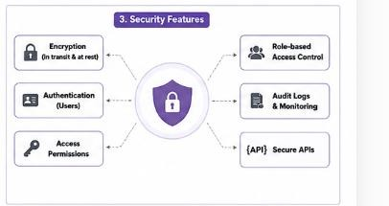

Benefits
The cloud-based collaboration system provides:
- Real-time collaboration.
- Access from multiple devices.
- Centralized document storage.
- Automatic synchronization.
- Version history.
- Global accessibility.
- Reduced requirement for local storage.
- Improved teamwork and productivity.
- High availability and scalability.

Conclusion
The Cloud-Based Document Collaboration System demonstrates how cloud computing enables users in different locations to collaborate on documents in real time. Distributed storage, APIs, version control, and global network infrastructure provide scalability and reliability. Security mechanisms such as encryption, identity management, and access
permissions ensure that documents remain protected.

Case Study 3: Online Food Ordering Platform

Introduction
An Online Food Ordering Platform is a cloud-based application that allows customers to browse menus, place orders, make payments, and track their orders through web browsers or mobile applications.
The system uses RESTful Web APIs to connect frontend clients with backend cloud services. Cloud storage is used for customer information, menu images, invoices, and other application data. Virtual machines and managed Kubernetes provide scalability and reliability for
backend applications.

System Architecture
The main components of the system are:

Frontend Client Layer
    - Web browsers.
    - Mobile applications.
    - Customers use these clients to browse menus and place orders.
    - Restaurant staff and administrators can use separate interfaces.

RESTful API Layer
    - Frontend clients communicate with backend services through REST APIs.
    - APIs handle operations such as:
      - User registration and login.
      - Menu retrieval.
      - Order creation.
      - Order updates.
      - Customer information.
      - Invoice generation.

Backend Services
    - Process customer requests.
    - Manage restaurant menus.
    - Process orders.
    - Manage customer accounts.

    - Handle business logic.

Cloud Storage
    - Stores menu images.
    - Stores invoices.
    - Stores customer-related data.
    - Provides scalable storage as the number of customers and restaurants increases.

Virtual Machines
    - Provide computing resources for application services.
    - Can be scaled according to application requirements.

Managed Kubernetes
    - Runs and manages containerized backend services.
    - Automatically manages application containers.
    - Supports scaling and service availability.
    - Helps distribute workloads across multiple computing resources.

Security Layer
    - Authentication tokens identify authenticated users.
    - HTTPS encrypts communication.
    - Role-Based Access Control (RBAC) controls permissions.

Cloud Service Models
The system uses different cloud service models:

Infrastructure as a Service (IaaS):
Virtual machines, networking, and other infrastructure resources provide the basic computing environment.

Platform as a Service (PaaS):
Managed Kubernetes and other managed cloud services provide platforms for running and scaling applications.

Software as a Service (SaaS):
The online food ordering application is delivered to customers through browsers and mobile applications.

RESTful Web APIs

RESTful APIs are a key component of the food ordering system. For example, an API may support operations such as:
- GET – Retrieve menu information.
- POST – Create a new food order.
- PUT – Update an existing order.
- DELETE – Remove or cancel a resource where permitted.
The API acts as a communication layer between frontend applications and backend cloud services.
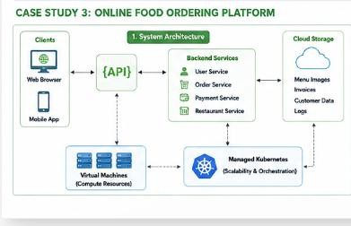

Scalability and Reliability
The platform may receive different levels of traffic. During lunch, dinner, weekends, or special events, the number of orders can increase significantly.
Cloud infrastructure and Kubernetes can help handle this situation by:
- Increasing the number of application instances.
- Distributing requests across multiple containers.
- Restarting failed containers.
- Managing application workloads automatically.
- Supporting high availability.
- Allowing resources to scale according to demand.

Security Measures
Security is particularly important because the platform handles customer accounts, orders, and potentially sensitive information.

The system uses:

Authentication Tokens:
Tokens are used to identify authenticated users and authorize API requests.

HTTPS:
HTTPS encrypts communication between clients and cloud services and helps protect information from interception.

Role-Based Access Control (RBAC):
Different users receive different permissions. For example:
- Customer: Browse menus and manage their own orders.
- Restaurant Staff: Manage menus and restaurant orders.
- Administrator: Manage users, restaurants, and system-level operations.

Secure Cloud Storage:
Access to stored customer information, invoices, and other data should be restricted to authorized services and users.

Benefits
The cloud-based food ordering system provides several advantages:
- Access through both web and mobile clients.
- Scalable infrastructure.
- Real-time order processing.
- Centralized cloud storage.
- High availability.
- Flexible resource management.
- Secure communication through HTTPS.
- Controlled access through RBAC.
- Easy integration through RESTful APIs.
- Support for large numbers of users.

Conclusion
The Online Food Ordering Platform demonstrates the integration of frontend clients, RESTful APIs, cloud storage, virtual machines, managed Kubernetes, and security services.
Cloud computing allows the platform to scale according to customer demand while
maintaining availability and reliability. Authentication tokens, HTTPS, and RBAC protect the application and its users.

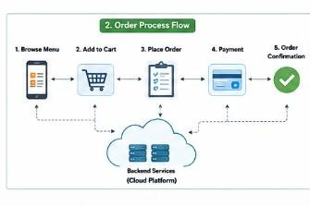

Overall Comparison of the Three Case Studies

Feature | Smart Retail Inventory | Document Collaboration | Online Food Ordering
Main Purpose | Inventory and demand management | Real-time document collaboration | Online food ordering
Clients | POS systems and dashboards | Web browsers and multiple devices | Web browsers and mobile apps
APIs | API-based  communication | Web APIs for  synchronization | RESTful Web APIs
Cloud Storage | Products, transactions, analytics | Documents and versions | Images, invoices, customer data

Main Platform Services | Analytics and forecasting | Collaboration and synchronization | Managed Kubernetes
Infrastructure | Cloud infrastructure, VPN, firewall | Global network infrastructure | Virtual machines and Kubernetes
Scalability | Handles multiple  stores and transactions | Handles many concurrent users | Handles varying order volumes
Security | VPN, firewall, API gateway | Encryption, identity management,  permissions | Tokens, HTTPS, RBAC
Primary Cloud Model | IaaS + PaaS + SaaS | Primarily SaaS | IaaS + PaaS + SaaS

Overall Conclusion
These three case studies demonstrate how cloud computing can be applied to different real-world business applications. Although their purposes are different, all three systems use
common cloud concepts such as clients, APIs, cloud storage, computing infrastructure, platform services, scalability, and security.
The Smart Retail Inventory Management System focuses on inventory control and data analytics. The Document Collaboration System focuses on real-time collaboration and distributed document storage. The Online Food Ordering Platform focuses on real-time transactions and scalable application services.
Cloud computing provides these systems with scalability, availability, flexibility,
centralized data management, and improved accessibility. At the same time, security mechanisms such as encryption, authentication, authorization, firewalls, VPNs, API
gateways, and role-based access control are essential for protecting cloud resources and user data.

